MACH4METAL

metalworking machinery
Transito 21
6909 DA BABBERICH Netherlands
Tel. +31 (0)316-247123
Fax: +31 (0)316-247956
info@mach4metal.com
www.mach4metal.com

Bank No : 66.52.13.883
IBAN : NL33 INGB 0665 2138 83
BIC : INGBNL2A

Kraftformer Walter Eckold KF 460

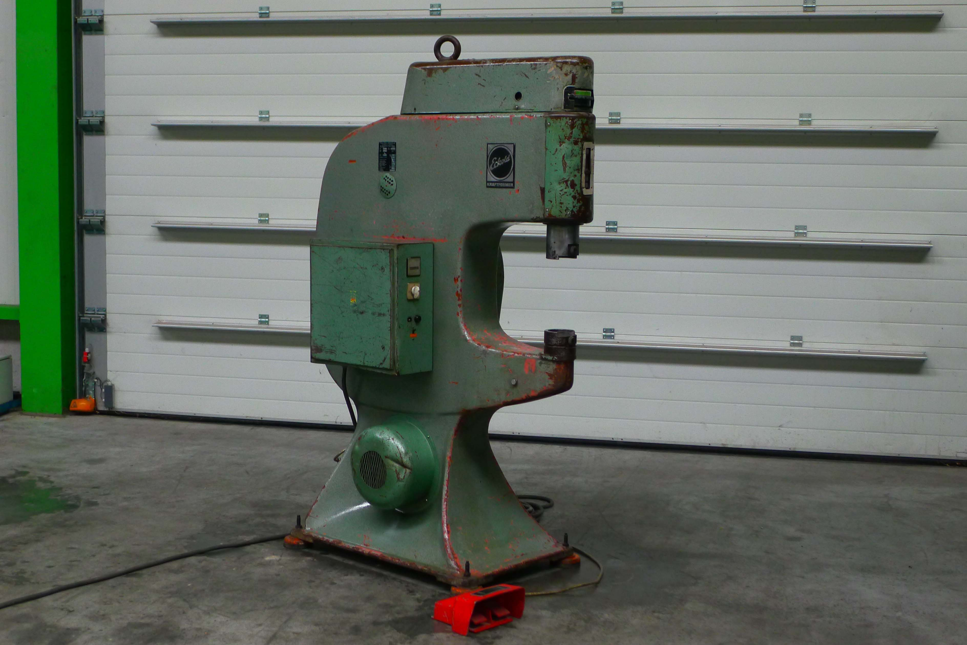
- Make : Eckold - Germany
- Typ : KF 460
- Serial.No : 3 / 472
- Age : 1968

- Throat Horizontal : 460
- Throat Vertical : 475

- Ram adjustment by motor ! : 60
- Working stroke : 8
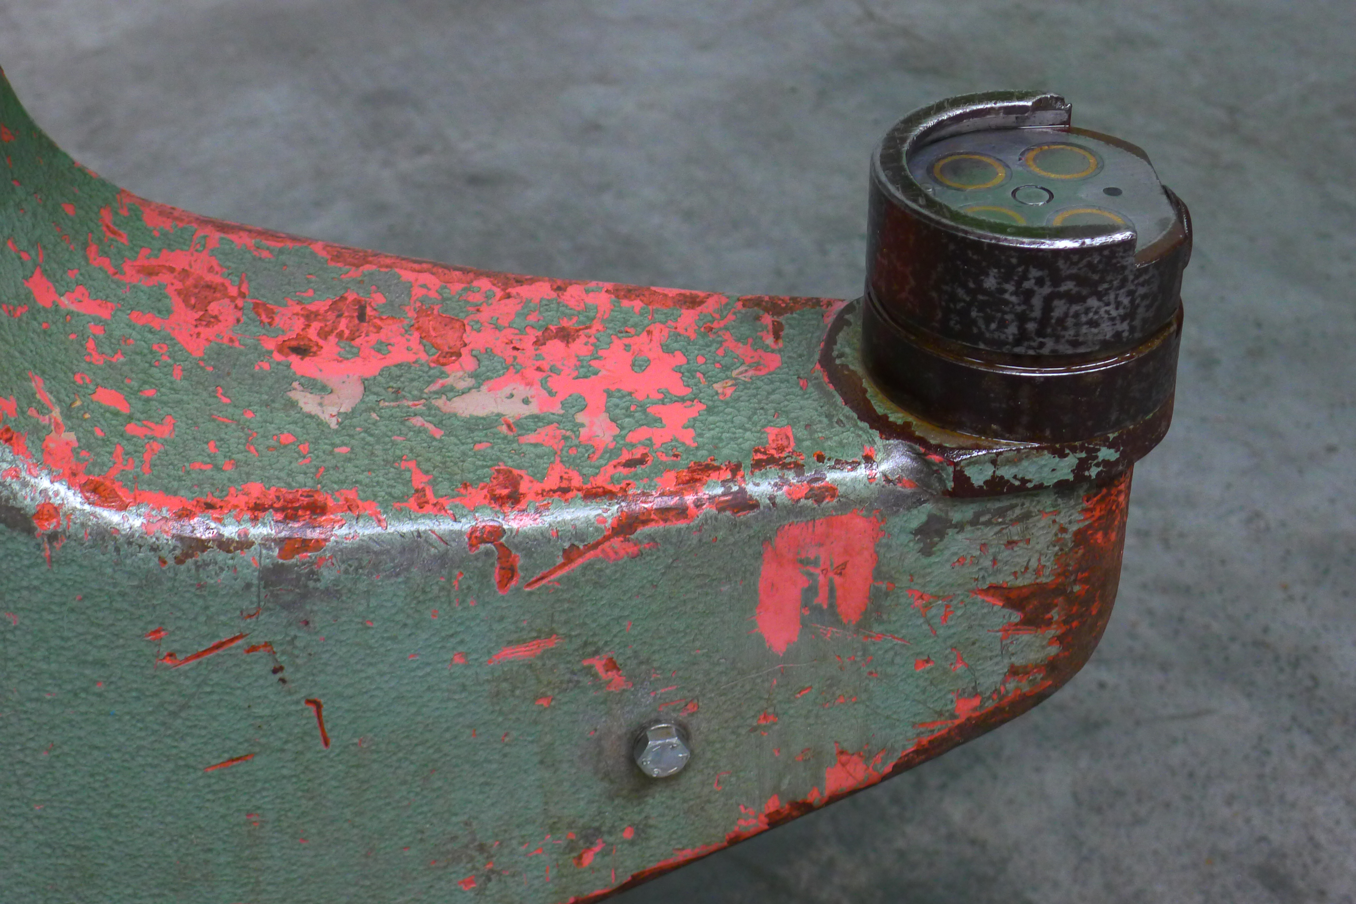
- Working strokes : 300 / 600

- Forming capacity:
- Steel 400 N/mm² : 3,0
- Alu 250 N/mm² : 4,0
- S.s. 600 N/mm² : 2,0

- Dimensions:
- L : 1.360
- W : 650
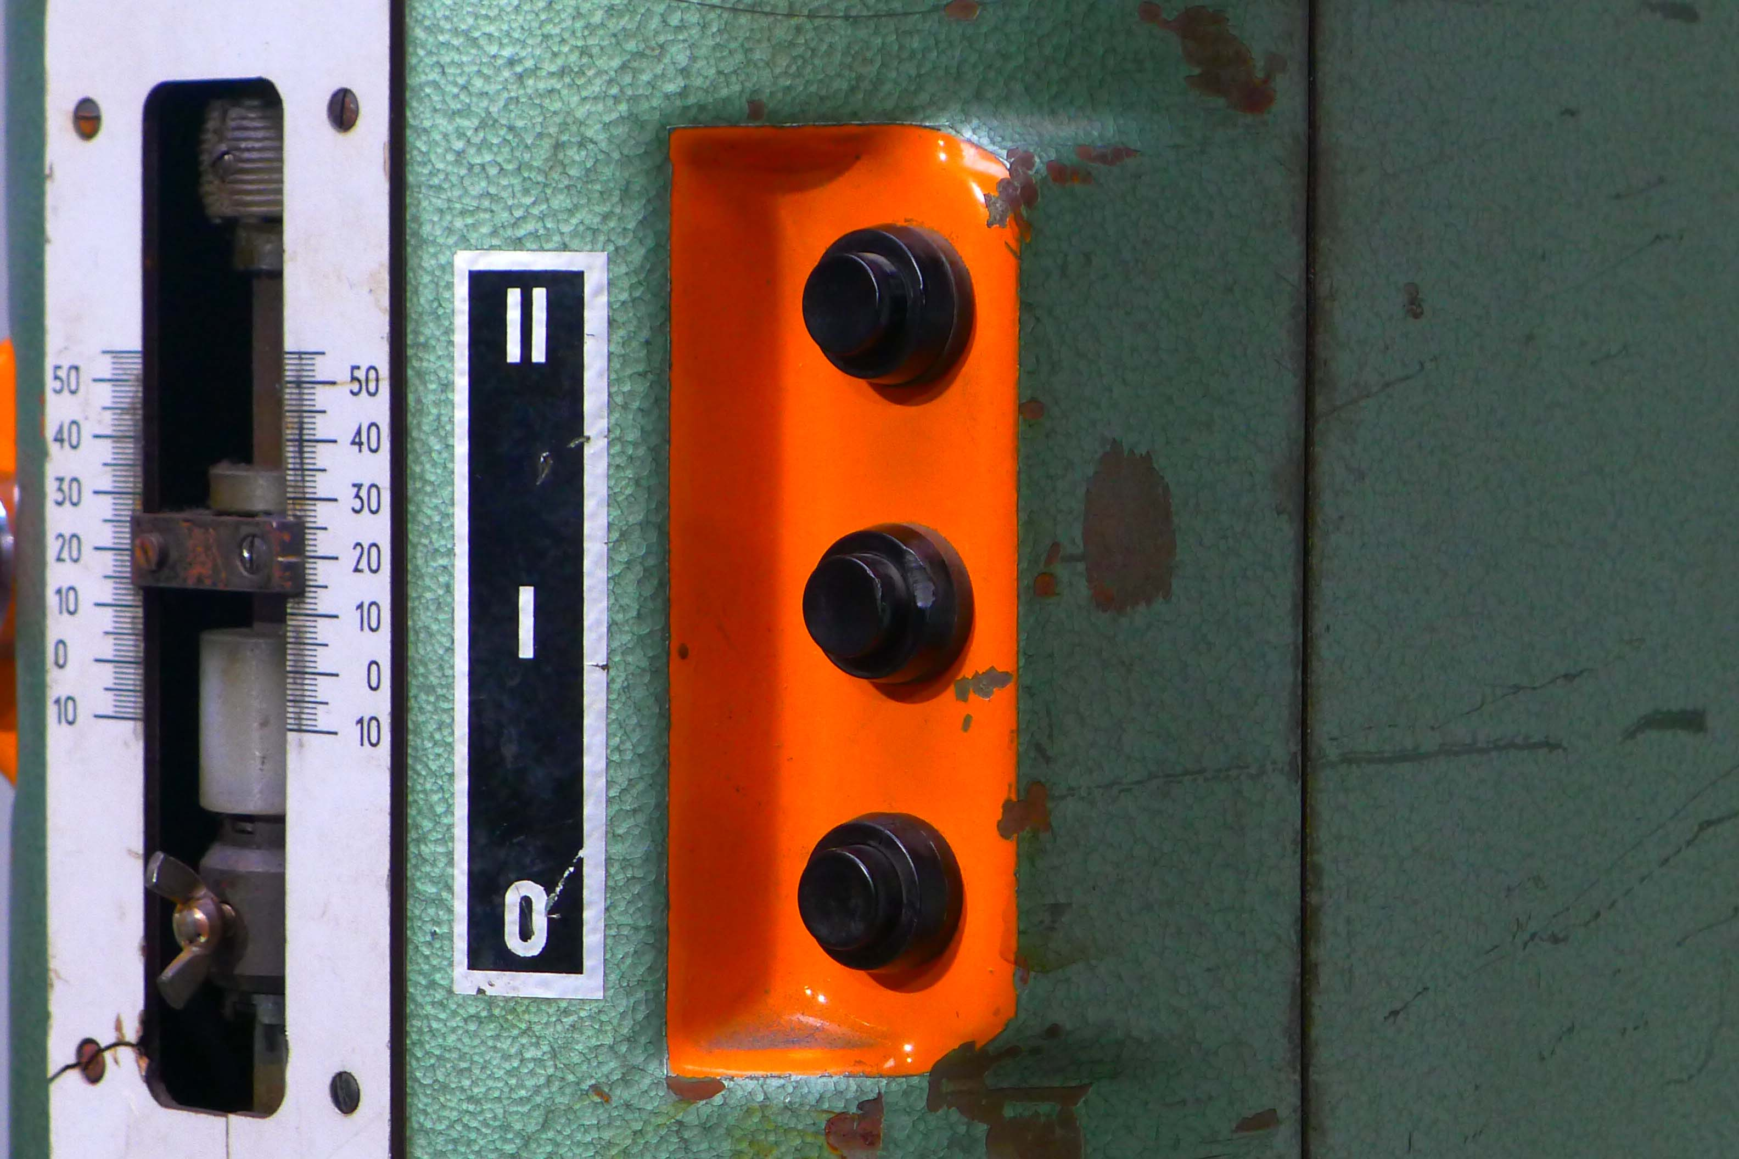
- H : 1.940
- W : 1.200

- Adj. upper ram by foot switch
- Machine is in working condition !

- incl. Documentation
- incl. foot panel switch
- incl. set ECKOLD tooling

Please Note: The above information has been obtained to the best of our ability and belief from, and from the manufacturers where possible. It is given in good faith, but its accuracy can not be guaranteed. Accordingly, it will not form a representation or constitute contractual terms. We advise you to check any vital details!

